|  |
| --- |
| **Experimentation (part 2)** |
| Follow the following steps and tasks. In some of them, you will be asked to take screenshots or record your time. |
| The collaborative configuration during this experiment will take place in a sequential way (workflow) where each participant will have a module to configure in a specific order according to a configuration plan defined by the product manager who will be in charge of assigning the configuration tasks to the participants.  *If you are reading this, then you are a participant. ☺* |

The web portal model that was configured during the first part of the experiment is now decomposed into several modules as shown in the following figure:

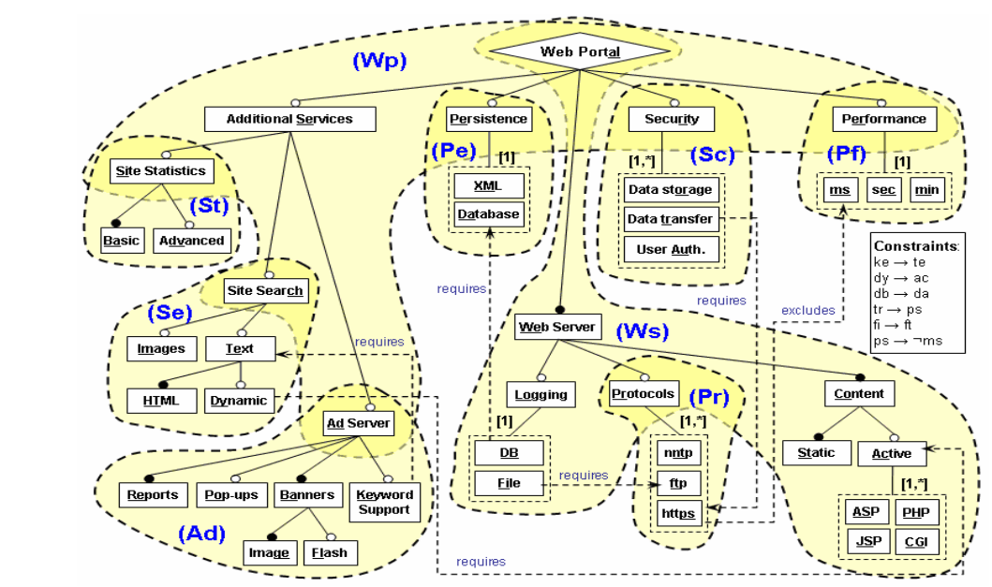

**Figure 1**: model of web portals broken down into modules.

These modules are linked according to two types of dependencies: high dependency and low dependency as illustrated by the dependencies network below.

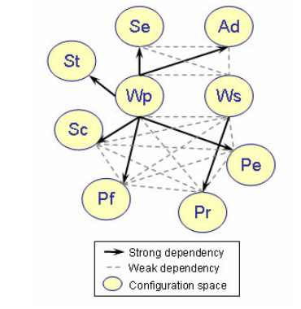

**Figure 2**: Dependencies network between modules.

Two modules that are highly dependent on each other must be configured sequentially. That in other words, if Module B is strongly dependent on Module A, A must be configured first. As is the case, for example, between module (Wp) and module (St), here (St) can only be configured after configuring (Wp) because the "Site Search" feature which is a connecting point between (Wp) and (St) will be configured in (Wp) where it is presented as a leaf. Depending on the decision of its configuration, (St) will be configured in (Wp). The same applies to all other highly dependent modules.

For low dependency modules, there is at least one "Exclude" or "Require" constraint between the characteristics that make up these modules. These modules can be configured sequentially or simultaneously. In the case of simultaneous configuration, the participants in charge of configuring these two modules are invited to negotiate possible alternatives in case of conflict.

* **Task 1 (Configure a Product)**

**Current time (put the time when you are ready to start this task):** HH: MM

1. Login with the login and password you chose in the first part of the experiment.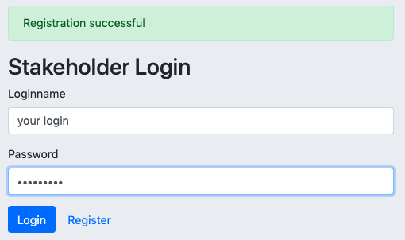
2. Import the XML file of the feature model to be configured through the following link: [github.com/sabrinacri/Colla-Config-tool/Web_portal_model.xml](https://github.com/sabrinacri/Colla-Config-tool/blob/main/Web%20portal_Domain-Webportal_model.xml)

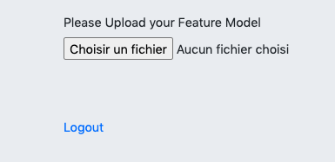

1. For ONLY the module assigned to you by the product manager, select ONLY the list of desired characteristics by checking the box 

For example, if the module to be configured is (St), then just configure the part about "Site Statistics" which corresponds to this part on the tool:

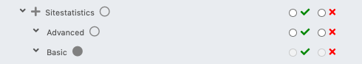

Take a screenshot of your module configuration choices and put it here:

|  |
| --- |
|  |

1. Communicate the screenshot of your choices to the product manager.
2. Click on « Save and close »
3. Click on « Logout »

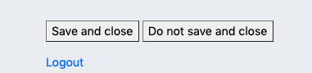

**Final time (record your current time after finishing this task):** HH: MM

* **Task 2 (Getting the conflict Resolution Result)**

The participant in the role of Product Manager will communicate the result to you at the end of the configuration process.